F7800G1 – TABUK – SPECIFICATION.
DELL HMI and Historian
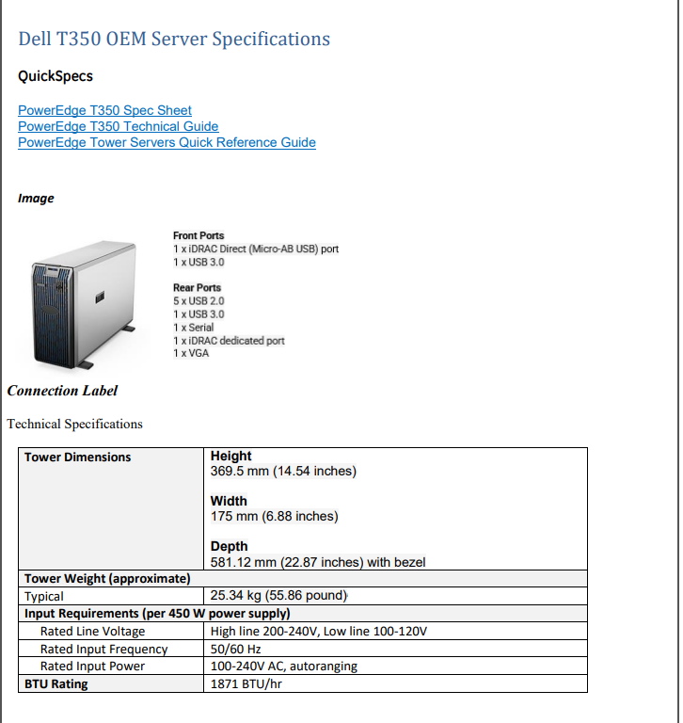

DELL – HMI
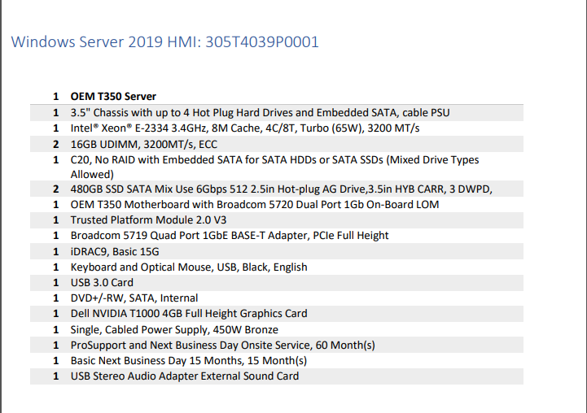

RAID Configuration Specification
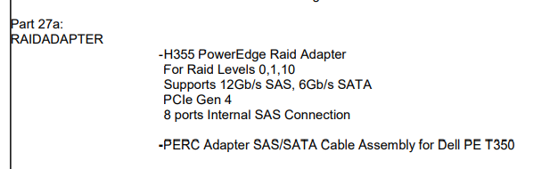

DELL HST
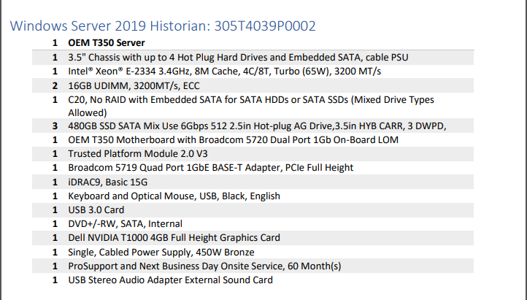

NOZOMI GUARDIAN Specification
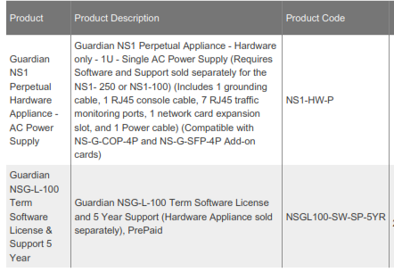

BSC – DELL R640 – BSC-HV1A -Hardware
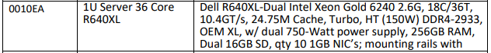

BSC- DELL R350 – BSC -HV2A – Hardware

